
In 2025, the operating hours of the NCU Sports Center (the tennis court included) will be adjusted in accordance with national holidays and school events as following:
114年9-12月，本校運動中心(含網球場) 因應國定假日及學校活動，營業時間調整如下:
日期 | Date | 節日/活動 | Event | 營運時間 | Operating Hours
9/28-29  (日~一) | SEP 28-29  (SUN-MON) | 教師節 | Teacher’s Day   | 全日  閉  館 | 
10/4-6  (六~一) | OCT 4-6  (SAT-MON) | 中秋假期   | Mid-Autumn Festival Holiday | 全日  閉  館
10/10  (五) | OCT 10  (FRI) | 國慶日 | National Day   | 全日  閉  館
10/24-25  (五~六) | OCT 24-25  (FRI-SAT) | 光復節   | Retrocession Day | 全日  閉  館
12/25  (四) | DEC 25  (THU) | 行憲紀念日 | Constitution Day | 全日  閉  館
11/5-6  (三~四) | NOV 5-6  (WED-THU) | 校運會活動 |   School Sports Day | 全日  閉  館
11/25  (二) | NOV 25  (TUE) | 校園路跑  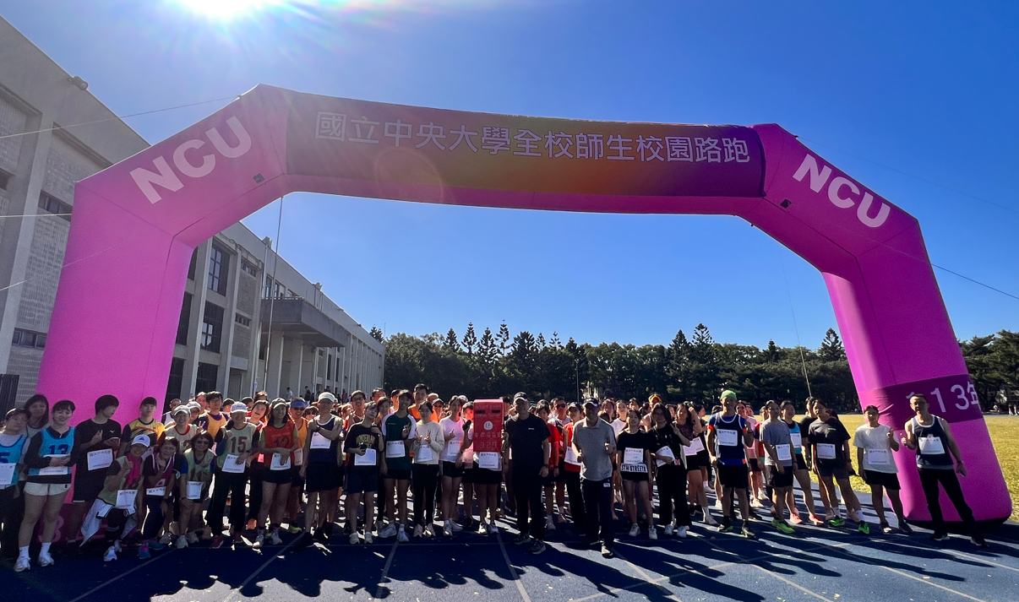 | Day of NCU RUN | 09:00-13:00  閉館 | Closed  09:00-13:00
體育室保有調整開放時間權利，如有未盡事宜，得依照現場公告/體育室官網公告為主The Physical Education Office reserves the right to adjust the opening hours. For any matters not covered, please refer to on-site announcements or the official website of the Physical Education Office.

